941-23 guruh talabasi Shonazarov Anvarbekning Mobil ilovalarni ishlab chiqish fanidan bajargan 8-amaliyot ishi

Mobil ilovalarda geolokatsiya xizmatlari va interaktiv xaritalar bilan ishlashni dasturlash

Loyiha geolokatsiya qismi
CRM loyihasida bog'cha joylashuvi alohida KindergartenLocation modeli orqali saqlanadi. Model latitude va longitude maydonlarini validatsiya qiladi hamda Google Maps va OpenStreetMap havolalarini hosil qiladi.
class KindergartenLocation(TimeStampedModel):
name = models.CharField(max_length=120, default="Anvar Bog'cha")
address = models.CharField(max_length=255, blank=True)
latitude = models.DecimalField(
max_digits=9,
decimal_places=6,
blank=True,
null=True,
validators=[MinValueValidator(-90), MaxValueValidator(90)],
)
longitude = models.DecimalField(
max_digits=9,
decimal_places=6,
blank=True,
null=True,
validators=[MinValueValidator(-180), MaxValueValidator(180)],
)
class Meta:
verbose_name = "Kindergarten location"
verbose_name_plural = "Kindergarten location"
def __str__(self) -> str:
return self.name
@classmethod
def get_solo(cls) -> "KindergartenLocation":
location, _created = cls.objects.get_or_create(pk=1)
return location
@property
def has_coordinates(self) -> bool:
return self.latitude is not None and self.longitude is not None
@property
def coordinates_display(self) -> str:
if not self.has_coordinates:
return ""
return f"{self.latitude}, {self.longitude}"
@property
def google_maps_url(self) -> str:
if not self.has_coordinates:
return ""
return f"https://www.google.com/maps/search/?api=1&query={self.latitude},{self.longitude}"
@property
def openstreetmap_embed_url(self) -> str:
if not self.has_coordinates:
return ""
lat = float(self.latitude)
lng = float(self.longitude)
bbox = f"{lng - 0.01:.6f}%2C{lat - 0.006:.6f}%2C{lng + 0.01:.6f}%2C{lat + 0.006:.6f}"
return f"https://www.openstreetmap.org/export/embed.html?bbox={bbox}&layer=mapnik&marker={lat:.6f}%2C{lng:.6f}"

Joylashuv ma'lumotlarini API orqali berish
Mobil yoki boshqa mijoz ilovalar bog'cha manzili, koordinatalari va xarita havolalarini REST API orqali olishi mumkin. Bu kelajakda mobil xarita ekranini qo'shish uchun tayyor asos yaratadi.
def serialize_location(location: KindergartenLocation) -> dict[str, object]:
return {
"name": location.name,
"address": location.address,
"latitude": str(location.latitude) if location.latitude is not None else None,
"longitude": str(location.longitude) if location.longitude is not None else None,
"has_coordinates": location.has_coordinates,
"google_maps_url": location.google_maps_url,
"openstreetmap_embed_url": location.openstreetmap_embed_url,
}

Interaktiv xarita tanlash
Web boshqaruv panelida Leaflet xaritasi ishlatiladi. Foydalanuvchi xaritani bosib yoki markerni sudrab GPS koordinatalarini tanlaydi, forma esa latitude va longitude qiymatlarini yashirin maydonlarda saqlaydi.
const locationMap = document.getElementById("locationMap");
if (locationMap && window.L) {
const latitudeInput = document.getElementById("id_latitude");
const longitudeInput = document.getElementById("id_longitude");
const coordinatesLabel = document.querySelector("[data-location-coordinates]");
const savedLat = parseFloat(locationMap.dataset.lat || "");
const savedLng = parseFloat(locationMap.dataset.lng || "");
const defaultLat = parseFloat(locationMap.dataset.defaultLat || "39.6542");
const defaultLng = parseFloat(locationMap.dataset.defaultLng || "66.9597");
const hasSavedCoordinates = Number.isFinite(savedLat) && Number.isFinite(savedLng);
const start = hasSavedCoordinates ? [savedLat, savedLng] : [defaultLat, defaultLng];
const map = window.L.map(locationMap, {
scrollWheelZoom: false,
}).setView(start, hasSavedCoordinates ? 16 : 12);
window.L.tileLayer("https://{s}.tile.openstreetmap.org/{z}/{x}/{y}.png", {
maxZoom: 19,
attribution: "&copy; OpenStreetMap",
}).addTo(map);
const markerIcon = window.L.divIcon({
className: "location-map-marker",
html: "<span></span>",
iconSize: [32, 32],
iconAnchor: [16, 30],
});
const marker = window.L.marker(start, { draggable: true, icon: markerIcon }).addTo(map);
function setCoordinates(latlng) {
const lat = Number(latlng.lat).toFixed(6);
const lng = Number(latlng.lng).toFixed(6);
if (latitudeInput) latitudeInput.value = lat;
if (longitudeInput) longitudeInput.value = lng;
if (coordinatesLabel) coordinatesLabel.textContent = `${lat}, ${lng}`;
marker.setLatLng(latlng);
}
if (hasSavedCoordinates) {
setCoordinates({ lat: savedLat, lng: savedLng });
}
map.on("click", function (event) {
setCoordinates(event.latlng);
});
marker.on("dragend", function () {
setCoordinates(marker.getLatLng());
});
function refreshMap() {
map.invalidateSize();
map.setView(marker.getLatLng(), map.getZoom(), { animate: false });
}
window.requestAnimationFrame(refreshMap);
window.setTimeout(refreshMap, 250);
window.setTimeout(refreshMap, 700);
}
1-rasm. Bog'cha joylashuvini xaritadan tanlash
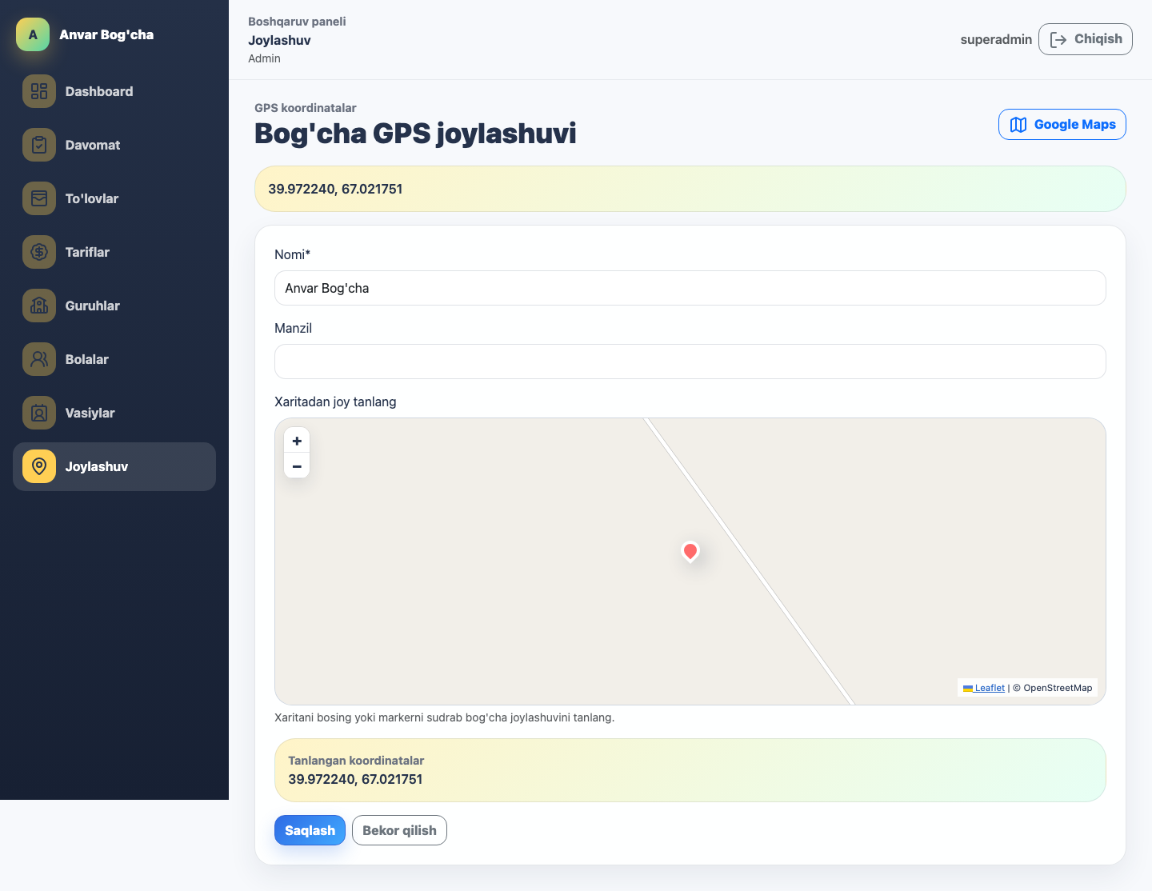
2-rasm. Mobil dashboardda bog'cha joylashuvi bloki
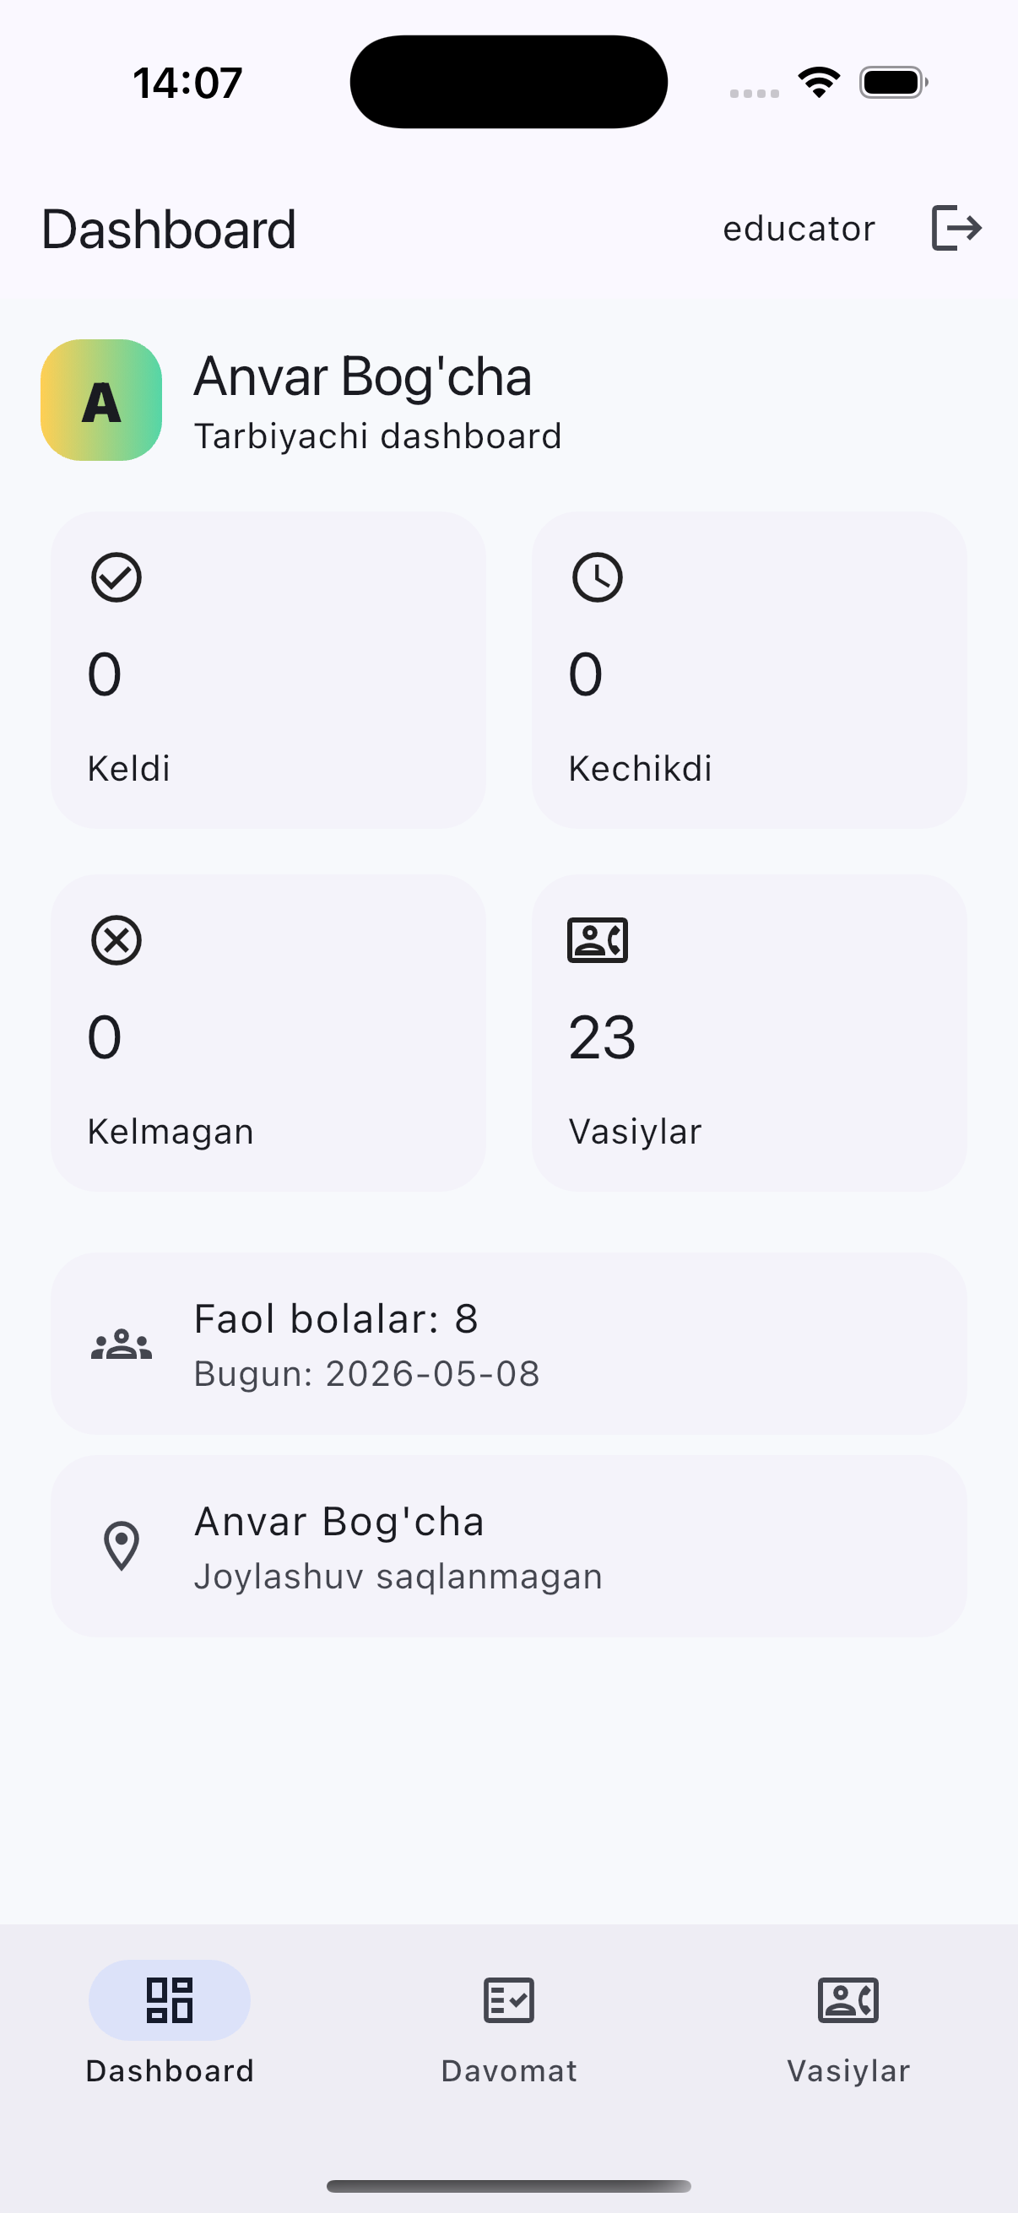

Xulosa
Ushbu amaliy ishda Anvar Bog'cha CRM loyihasi uchun mobil ilova, REST API, token autentifikatsiya, davomat va vasiylar bilan ishlash jarayonlari ko'rib chiqildi. Ilova iOS simulatorda ishga tushirilib, asosiy ekranlari tekshirildi.

